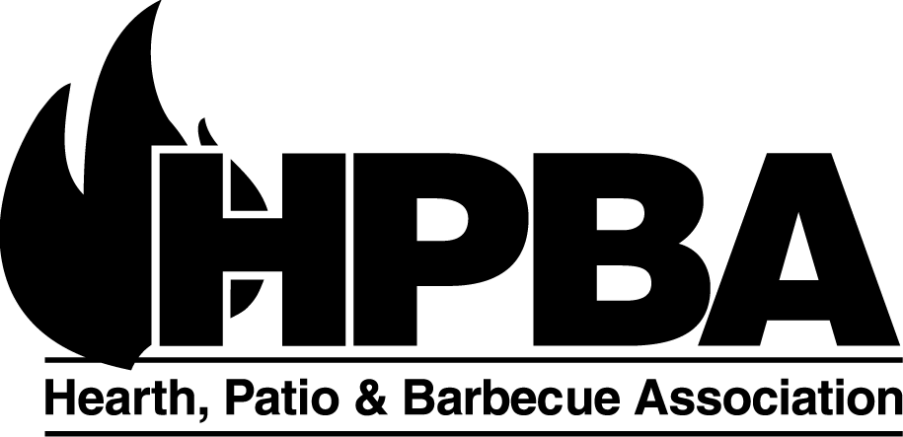
Suite 600, 1901 North Moore Street
Arlington, VA 22209 USA
Phone: (703) 522-0086 • Fax: (703) 522-0548
Email: hpbamail@hpba.org
Web Site: www.hpba.org

For Immediate Release Contact: Sue Crosby
(703) 522-0086 ext 116
crosby@hpba.org

HPBA Submits Comments to EPA on Proposed NSPS
Industry concerned that proposed standards will mean slow clean air progress

Arlington, VA (May 5, 2014) – The Hearth, Patio & Barbecue Association (HPBA) submitted its comments to the Environmental Protection Agency (EPA) today in response to the Agency’s proposed New Source Performance Standards (NSPS) for Residential Wood Heaters.

“We are glad to have the opportunity to submit our comments to EPA. The hearth products industry welcomes EPA's efforts to update standards for our wood burning products. The industry also supports meaningful emissions reductions to improve air quality. Unfortunately, some of the standards proposed for the appliances do not meet the government’s duty to set standards based on data that show both a tangible benefit to consumers and cost-effectiveness,” said Jack Goldman, President & CEO of HPBA.

In the comments, HPBA addresses the flaws with the new set of requirements. The Agency has set a very low emissions limit that is difficult to meet; made changes to the analytical methodology, which increases the difficulty in determining whether or not an appliance even complies with the new standard; and changed the test fuel, where there is no agreed-upon data or method in use. These changes collectively make the new limits exceedingly difficult to achieve – even in a highly-controlled laboratory environment.

The current proposal would have the perverse effect of slowing clean air progress. Consumers will choose to hold on to their older, high-polluting stoves rather than invest a significant amount of money in a much more costly new appliance that has no guarantee of improving air quality.

“We are hopeful that our thoughtful, fact-based comments will help guide the EPA in setting regulations that are achievable, cost-effective, and helpful in reaching our common goal of cleaner air for the public,” says Goldman.

HPBA will continue efforts to work with the EPA, state governments, and members of Congress on the best ways to reduce wood smoke emissions.

###

About Hearth, Patio & Barbecue Association (HPBA) The Hearth, Patio & Barbecue Association (HPBA), based in Arlington, VA, is the North American industry association for manufacturers, retailers, distributors, representatives, service firms in the hearth industry. The association provides professional member services and support in education, statistics, government relations, marketing, advertising, and consumer education. There are more than 2500 members in the HPBA.

